AI Powered Intelligent Hospital Patient Flow Management System
CONCLUSION, FUTURE SCOPE AND REFERENCES

Student | Hall Ticket No.
A. RAMU | 23K91A6715
B. RUSHI | 23K91A6720
B. RAJ KUMAR | 23K91A6725
A. PRABHAS | 23K91A6703
Under the guidance of [GUIDE NAME]
Department of Computer Science and Engineering (Data Science)
[COLLEGE NAME]
[ACADEMIC YEAR]

1. Conclusion
CareFlow demonstrates an integrated, role-based hospital patient-flow prototype that connects registration, AI-assisted prioritisation, token queues, consultation, laboratory work, bed/ICU state and operational dashboards. The implementation is functional on the supplied local environment and all measured read endpoints passed the defined smoke run.
The strongest result is integration rather than clinical prediction. The wait regressor achieved R-squared 0.951041 on a generator-matched synthetic test and the triage classifier achieved 96.80% accuracy, but the latter recalled only 63% of critical cases. These results justify continued engineering investigation, not autonomous care decisions.
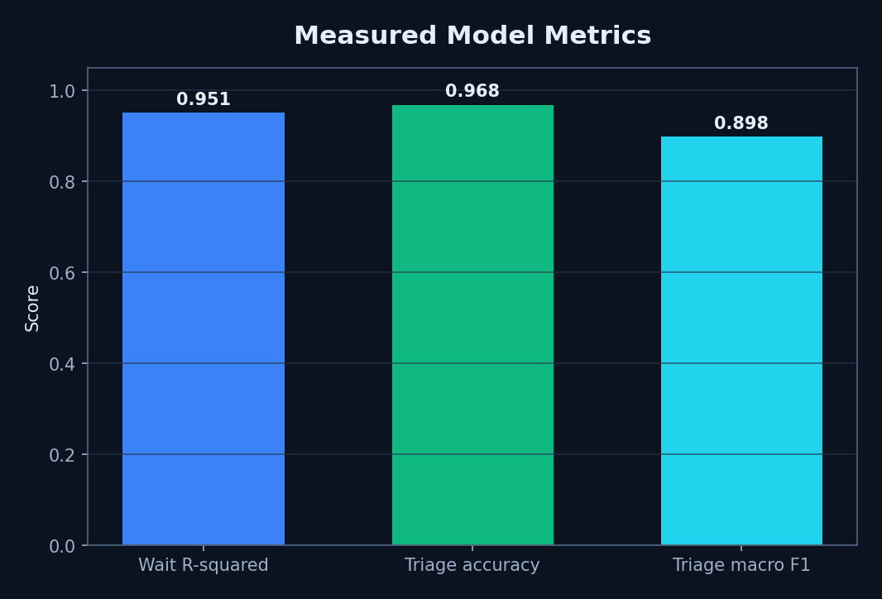
Figure 1. Summary of measured model results.

2. Key Findings
A single persisted Visit model lets role dashboards agree on token, status, priority and predicted wait. Priority-aware queue sorting is simple and auditable. Movement logs make explicit department changes inspectable. Bed and laboratory modules expose the operational dependencies that ordinary appointment applications omit.
The evidence also shows where design work remains: model safety is class-dependent, state transitions require tighter coupling, the initial nurse tab is faulty, and production security/scaling mechanisms are not present.

3. Future Scope
Table 1. Prioritised future scope.
Priority | Future work | Expected evidence
1 | Validate on de-identified real patient-flow data with ethics and governance approval | External temporal test and subgroup metrics
2 | Optimise critical recall with cost-sensitive learning and calibrated thresholds | Safety-focused confusion matrices
3 | Integrate HL7 FHIR with hospital EHR, lab and admission systems | Interoperability conformance tests
4 | Replace SQLite and in-process WebSocket with production services | Concurrent load, resilience and recovery tests
5 | Authenticate live channels; rotate secrets; add audit and privacy controls | Security assessment
6 | Fix dashboard state coupling and nurse default tab | Automated end-to-end tests
7 | Forecast demand and recommend staffing/bed plans | Prospective operational study

4. Known Limitations
Both model datasets are synthetic and generated from designed distributions; they are not real patient records.
The measured model test partitions come from the same deterministic generators as training and are not independent clinical validation.
No real hospital deployment, clinician study, user-acceptance study, security audit, accessibility audit, or concurrent-load test was performed.
The 96.80% triage accuracy must be interpreted with the 63% critical-class recall; accuracy alone overstates safety-critical performance.
SQLite, a development JWT secret fallback, an unauthenticated WebSocket, and in-process broadcasting are unsuitable for production without hardening.
The landing-page claims of 42% wait reduction, 214 patients, and six departments are hard-coded marketing copy and are excluded from results.

REFERENCES
[1] S. A. N. Saritha, G. Kalnoor, P. R. Bhat, P. A. Rao, P. Prajwal, and P. T. Pradeep, ‘Alleviate: An AI-Powered Mobile Application for Personalized Healthcare Management and Doctor Recommendation,’ IEEE Access, vol. 13, pp. 215822–215832, 2025, doi: 10.1109/ACCESS.2025.3647089.
[2] S.-K. Tan, S.-C. Chong, K.-K. Wee, and L.-Y. Chong, ‘Personalized healthcare: A comprehensive approach for symptom diagnosis and hospital recommendations using AI and location services,’ Journal of Informatics and Web Engineering, vol. 3, no. 1, pp. 117–135, 2024.
[3] M. Abinaya and R. Ganesan, ‘Effective search mechanism for finding nearest healthcare facilities,’ in Proc. Global Conference on Communication Technologies, 2015, pp. 534–538.
[4] M. W. Munir, S. M. Omair, and M. Z. U. Haque, ‘An Android based application for determine a specialized hospital nearest to patient’s location,’ International Journal of Computer Applications, vol. 118, no. 9, pp. 43–46, 2015.
[5] R. A. Nimbalkar and R. A. Fadnavis, ‘Domain specific search of nearest hospital and healthcare management system,’ in Proc. Recent Advances in Engineering and Computational Sciences, 2014, pp. 1–5.
[6] A. Kumar, ‘Disease prediction and doctor recommendation system using machine learning approaches,’ International Journal for Research in Applied Science and Engineering Technology, vol. 9, no. 7, pp. 34–44, 2021.
[7] L. Bjorkdahl, O. Pauli, J. Ostman, C. Ceccobello, S. Lundell, and M. Kjellberg, ‘Towards holistic disease risk prediction using small language models,’ arXiv:2408.06943, 2024.
[8] R. Umbare, R. Patil, T. Mukund, A. Rathod, and P. Rajurkar, ‘A smart healthcare application using artificial intelligence and machine learning,’ in Proc. ICIPCN, 2024, pp. 204–210.
[9] D. Gujar, R. Biyani, T. Bramhane, S. Bhosale, and T. P. Vaidya, ‘Disease prediction and doctor recommendation system,’ International Research Journal of Engineering and Technology, vol. 5, pp. 3207–3209, 2018.
[10] D. Mogaveera, V. Mathur, and S. Waghela, ‘E-health monitoring system with diet and fitness recommendation using machine learning,’ in Proc. ICICT, 2021, pp. 694–700.
[11] P. Tanwar, K. Bansal, A. Sharma, and N. Dagar, ‘AI based chatbot for healthcare using machine learning,’ in Proc. ICAICCIT, 2023, pp. 751–755.
[12] R. Surve, T. Purohit, R. Joseph, and P. Shaikh, ‘Healthcare chatbot using machine learning and NLP,’ in Proc. ICAST, 2023, pp. 411–416.
[13] H. Mendapara, S. Digole, M. Thakur, and A. Dange, ‘AI based healthcare chatbot system using natural language processing,’ International Journal of Scientific Research and Engineering Development, vol. 4, no. 2, pp. 89–96, 2021.
[14] M. M. Rahman et al., ‘Web-based multiple disease prediction system with transfer learning and healthcare chatbot,’ in Proc. IEEE ICMI, 2024, pp. 1–5.
[15] J. Tseng et al., ‘An interactive healthcare system with personalized diet and exercise guideline recommendation,’ in Proc. TAAI, 2015, pp. 525–532.
[16] T. Bhanuteja, K. V. N. Kumar, K. S. Poornachand, C. C. V. N. Ashish, and P. Anudeep, ‘Symptoms based multiple disease prediction model using machine learning approach,’ IJITEE, vol. 10, no. 9, pp. 67–72, 2021.
[17] ‘Waiting Time Prediction in Queue Management: Leveraging Machine Learning Approach,’ in Proc. International Conference on Recent Progresses in Science, Engineering and Technology, 2024.
[18] ‘Prediction of outpatient waiting time using machine learning in a tertiary children’s hospital,’ Translational Pediatrics, 2023.
[19] ‘Dissatisfaction-considered waiting time prediction for outpatients with interpretable machine learning,’ Health Care Management Science, 2024.

